Plans and Progress

**Inception of this project and assigned roles**

When we were first looking for an IT project to undertake, we have pondered several ideas on discord chat, and discussed several IT applications. After some debate, namely myself, Sam and Jacob, we finally settled on a fitness application. We asked everybody that we chose the fitness app, and if there no objections, then we would commence the project plan. The fitness application traces back to Jacob’s first assignment, and after some discussion about this app, we decided to embark on this opportunity. Once we knew what our IT project will be, we started to break down on requirement of assignment 3 and worked on each of our member’s responsibilities in the project: The responsibilities include:

Kim Ve - Setup Github repository and regulate

Aims

Plans and Progress

Sam - Scope and Limits

Team Profile

Tools

David Roles

Tools Technique

Jacob Risks

Group Processes

Scott Testing

Time-frame

Group Feedback

Group reflection

**Current progress**

With the assigned task delegated to our group, some of the members have started to work on the project. Kim Ve has started on the aim of the project and produced a preliminary scope and limits to assign some parameters on the fitness application. With the prescribed aim mentioned earlier, and how the application design will cater fitness users, Sam and Kim Ve have mostly outlined the finer details of the project, such as Sam needing information on the fitness program, meal plans, exercise frequency and intensity. And Sam was wondering how we can incorporate the mobile phone camera exclusive feature in this project. Unfortunately, as we discussed further on, that feature cannot be part of this assignment but rather, a project pitch that qualifies as a feasibility test. Below is a picture sample of our discussion on various parts of the assignment, as Kim Ve, Samuel and to an extent Jacob were the only ones active at this stage.

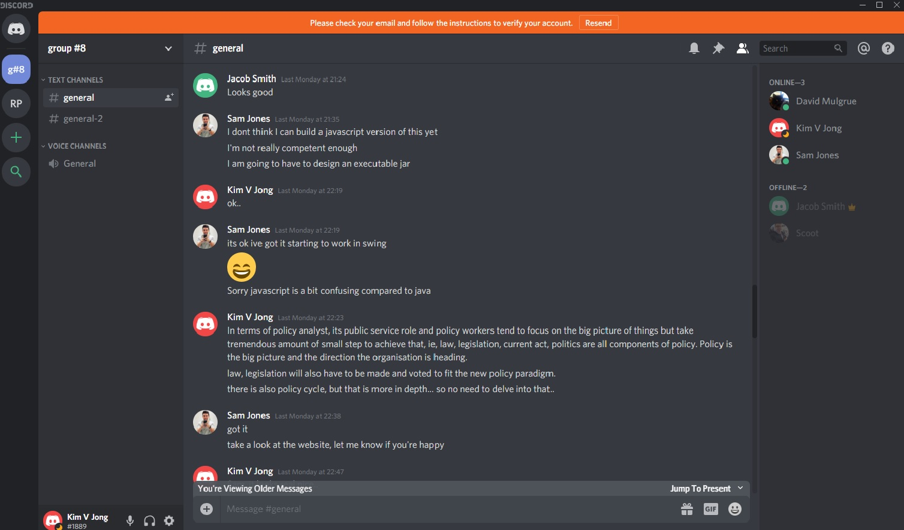

By this stage, Kim Ve has contributed to the early parameters of scope and limits for Samuel, as he needed basic information so he can code. The information needed to code was perhaps the most tedious bit in our discord conversation, as information needed to be relayed in an accurate way so coding can be done correctly. Kim Ve then typed up some parameters to outline the scope and limits for Samuel to work with, but by then samuel understood the concept well enough and developed the scope much further.

**Core concept of the fitness applications**

The program is designed for beginners and intermediate fitness users that want to use the phone app as an addition to aid in their fitness journey. For beginners, it will guide them on the exercise to be done, how many reps to do, and how many times per week they can commit to. The program will also have a daily food intake recommendation for the exercise the user has undertaken, such as the amount of protein ratio relatively to their weight. The user can also choose calorie deficit for weight loss / cutting or calorie increase to bulk up. The fitness program will have four programs in total for the user: the first 3 months, then from 3-6 months, 6-12 months and after the first year. The reason as to why the program is concentrated on the first year, is if the fitness personnel has followed the program thoroughly, then the most gain will be in the first year. After the first year and subsequent year after that, the gains will be diminished, but the fitness program will still continue to maintain the body level fitness. And finally, the program will prompt the user for their exercise style: Bodybuilding or athletic regimen.

**Functionality of the program**

* First the program will prompt the user for

- age (a)

- sex (b)

- weight (c)

* Next the fitness program will prompt the user for type of training:

- athletic (d)

- bodybuilding (e)

- athletic and bodybuilding (f)

* And the third question will prompt the user for frequency of training

- 3 days per week (g1 and g2) – These are intensity level 1 and 2

- 4 days per week (h1 and h2)

- 5 days per week (i1 and i2)

- 6 days per week (j1 and j2)

* Next is the calorie of food intake:

- 1600kj (l)

- 1800kj (m)

- 2000kj (n)

- 2200kj (o)

- 2400kj (p)

- 2600kj (q)

- 2800kj (r)

- 3000kj (r)

* The next workout level is the rep:

rep 1 – 3-6 (s) – done 3 times

rep 2 – 6-10 (t) – done 3 times

rep 2 – 10-15 (u) – done 2 times

aerobic (v) – includes rowing, treadmill and static bicycle

**Core** – Core exercise includes abs, obliques, lower back and glutes

**Upper body** – Includes the main muscle group of bicep, tricep, pecs, trapezius, rhomboids, forearm and rotator cuff

**Lower body** – quads, hamstring, glutes and calves

* If user selects age between 18-35, then use g1

If user age is over 35+ then select g2

* If Sex is male then 100% regiment specified

If sex is female then 80% regiment specified based on weights versus the male counterpart

* For weight, if BMI (Body Mass Index) is under, then select above 3 days or any days

If weight is over BMI, then the user cannot go above 4 days

(you may have to create a BMI table for this)

**For athletic exercise regimen: Weekly exercise**

The user can select any day of the week they choose to exercise:

- 3 days (d, g1) – intensity level 1

Day 1 aerobic (v) (endurance) x1

core x1 (t)

Day 2 core x1

upper body x1 (t)

Day 3 aerobic x1 (v)

lower body (u)

- 3 days (d, g2) – intensity level 2

Day 1 aerobic x2 (v)

core x2 (s, t)

upper body x2 (t, u)

Day 2 Lower body x2 (t, u)

core x2 (t, u)

Day 3 aerobic x1 (v)

core x1 (u)

upper body x2 (t, u)

lower body x1 (u, u)

- 4 days (d, h1)

Day 1 aerobic x1 (v)

Upper body x1 (t)

Day 2 Lower body x1 (t)

Core x1 (t)

Day 3 aerobic x1 (v)

Upper body (u)

Day 4 Core x1 (t)

Lower Body (u)

4 days (d, h2)

Day 1 aerobic x1 (v)

Core x2 (t, u)

Upper body (t,u)

Day 2 aerobic x1 (v)

Lower Body x2 (t,u)

Day 3 Upper body x2 (t,u)

Core x1 (u)

Day 4 aerobic x1 (v)

Core x1 (t)

Lower Body (s,u)

Upper body (s,u)

5 days (d, i1)

Day 1 aerobic x1 (v)

upper body x1 (u)

Day 2 core x1 (u)

lower body (u)

Day 3 aerobic x1 (v)

upper body x1 (t)

Day 4 core x1 (t)

lower body (t)

Day 5 aerobic x1 (v)

upper body x1 (s)

5 days (d, i2)

Day 1 aerobic x1 (v)

Core x1 (t)

Upper body x2 (t, u)

Day 2 aerobic x1 (v)

lower body x2 (t, u)

Core x1 (u)

Day 3 Core x1 (u)

Upper body x2 (t, u)

lower body x1 (u)

Day 4 aerobic x2 (v)

lower body x1 (t)

Day 5 aerobix x1 (v)

core x1 (t)

lower body x1 (u)

upper body x1 (u)

6 days (e, j1)

Day 1 aerobic x2 (v)

Day 2 aerobic x1 (v)

upper body x1 (u)

Day 3 core x1 (u)

lower body x1 (u)

Day 4 aerobic x1 (v)

upper body x1 (t)

Day 5 core x1 (t)

lower body x1 (t)

Day 6 aerobic x1 (v)

core x1 (u)

upper body x1 (u)

6 days (e, j2)

Day 1 aerobic x1 (v)

core x2 (t, u)

upper body x2 (t, u)

Day 2 aerobic x1 (v)

lower body x2 (t, u)

upper body x1 (u)

Day 3 Core x2 (t, u)

upper body x1 (t)

lower body (t)

Day 4 aerobic x1 (v)

core x1 (u)

upper body x1 (u)

Day 5 aerobic x2 (v)

lower body x1 (u)

Day 6 aerobic x1 (v)

core x2 (t, u)

upper body x1 (s)

lower body x1 (t)

**Update**

Things have started rather slow with everyone being busy. Scott had some big IT project work and family and thus was not actively involved, and perhaps was the hardest to reach to in recent weeks. If we had some minor adjustments to the project, it could not be done. Other members had to pick up the adjustments that was to be made. David fell ill for a few weeks and was not active for at least two weeks, and communication was severely lacking. Jacob has been assigned with tasks and still communicates on a weekly basis but quite minimal. Samuel and Kim Ve have been quite active in keeping the project together and keeping tabs on the progress on the assignment. Kim Ve however has worked long hours 12-14 hours for the last week and a bit to chase up on back-log with his work, and have fallen a little behind in our scheduled work, but have still maintained the overall requirements and presented the modules on time for others to work on. And Sam has finished his project task early with a bit of room to overlook other aspects of the project and delve further into the assignment requirements, and look for gaps that we might have missed. In addition, we have expanded the feature further with the inclusion of an education component as a sub feature to educate fitness users on the correct form of the workout and thus avoid injuries and placing safety first. We would also research as an additional feature on a functional app to have articles and videos on progression and meal plans. Though this feature is only considered on a functional app.

**References**

Abdesselam, R 2013, A Framework for Mobile Application Design, *International Journal of Computer Science Issues*, Vol 10, Issue 3, pp.218-224.

Caterisano, A, Hutchinson, R, Parker, C, James, S & Opskar, S 2018, Improved Functional Power Over a 5-week period: comparison of Combined Weight Training to Flexible Barbell Training, *Journal of Strength and Conditioning Research*, Vol 32, Issue 8, pp.2109 – 2115.

Mackenzie, K, Byrne, N, Slater, G & King, N 2015, The effect of a whey protein supplement does on satiety and food intake in resistance training athletes, *Appetite*, Vol 92, pp. 178-184.